

**Course Name**: DIGITL LOGIC DES LAB

**Course Number and Section**: **14:332:233:01**

**Experiment**: Lab 6 Prelab

**Lab Instructor**: ZAHRA AREF

**Date Performed**: 11/15/2024

**Date Submitted**: 11/15/2024

**Submitted by**: Chance Reyes 225006531

**Course Name**: _________________

**Course Number and Section**: **14:332:xxx:xx**

**! Important: Please include this page in your report if the submission is a paper submission. For electronic submission (email or Sakai) please omit this page.**

--------------------------For Lab Instructor Use ONLY--------------------------

GRADE: _______________

COMMENTS:

1- Explain your understanding of the design problem and describe the goal of the experiment

in your own words.

**The design task is to create a traffic light that prioritizes the main road but switches the lights to allow pedestrians to walk across the crossroad when a button is hit. This system will keep the main road green until the walk button is triggered by a pedestrian. When the button is hit, the main light goes to amber (4 seconds), then the main light and cross light go to red and green, respectively for 8 seconds. Finally, the main light and cross light go back to green and red, respectively. The goal is to let both cars and pedestrians pass in a safe manner by following a specific time sequence of the lights.**

2- Describe your own understanding of what a state diagram is, how it is being constructed,

and how it generally can help in designing finite state machines.

**A state diagram represents a finite state machine. Each element on a diagram represents a unique state of the system and has paths to show how one state transitions to the next. These diagrams are useful for visualizing how a state machine functions and makes designing and debugging them easier.**

3- Draw a state diagram for the described traffic signal controller, showing all the discrete

states of your system, and the conditions for transitioning between states.

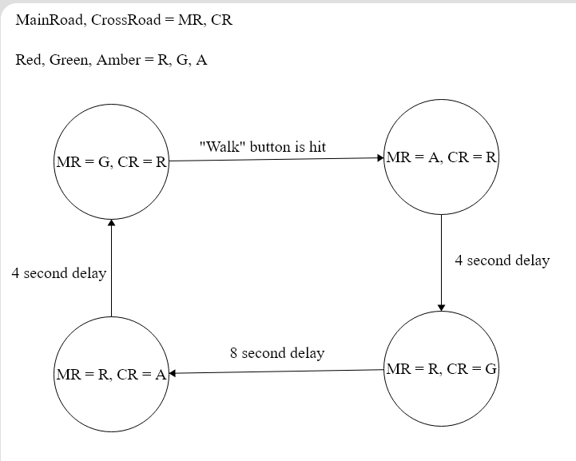

4- Propose a design solution. Provide a preliminary schematic of your proposed circuit.

Identify the logic gates needed.

**Logic gates needed: 2 Latch IC, 555 Timers, NOT gates**

.